**Experiment:** Applying SVM to centered and shifted images for classifying digit 8 (positive class) and digit 6 (negative class)

**Centered images:** the digit image (28*28 pixels) would be placed on the center of a zero matrix of 56*56. The examples for digit 8 and digit 6 are shown in Figs. 1 and 2 correspondingly.

**Shifted images:** the digit image (28*28 pixels) would be placed on the random position of a zero matrix of 56*56 (which is ensured to contain the whole digit image). The examples of shifted digit 8 and shifted digit 6 are shown in Figs. 3 and 4 correspondingly.

Linear SVM is applied to the shifted images and centered images respectively for classifying digits 8 and 6.

- 200 training data 200 (100 for each class) is used to estimate the SVM classifier.

- 200 validation data 200 (100 for each class) is used to select the optimal model.

- 1000 test data: 1000 (500 for each class) is used to evaluate the prediction performance.

The prediction results on centered images and shifted images are shown in Table 1. SVM shows a very good prediction performance on classifying the centered images (digit 8 vs. digit 6). However, the prediction performance declines significantly on shifted images (shifted digit 8 vs. shifted digit 6). The results suggest that randomly shifting the digit images increase the difficulty of prediction task significantly.

Table 1. Prediction results on centered/shifted images

|  |  |  |  |
| --- | --- | --- | --- |
| Centered images | | | |
| Training SS | Training SP | Test SS | Test SP |
| 0.99 | 0.99 | 0.98 | 0.98 |
| Shifted images | | | |
| Training SS | Training SP | Test SS | Test SP |
| 0.95 | 0.93 | 0.53 | 0.53 |

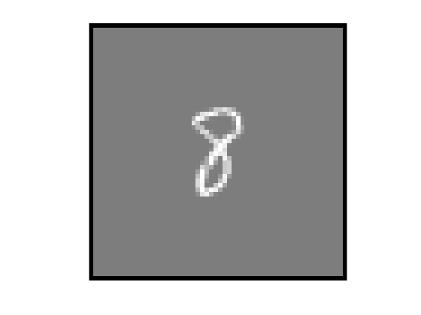



Fig. 1. Four examples of centered digit 8

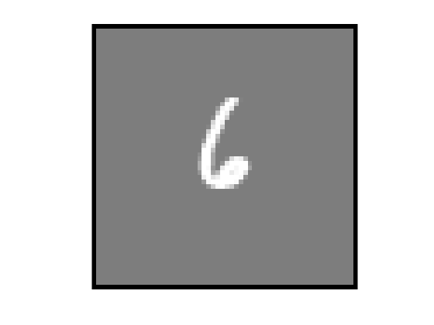

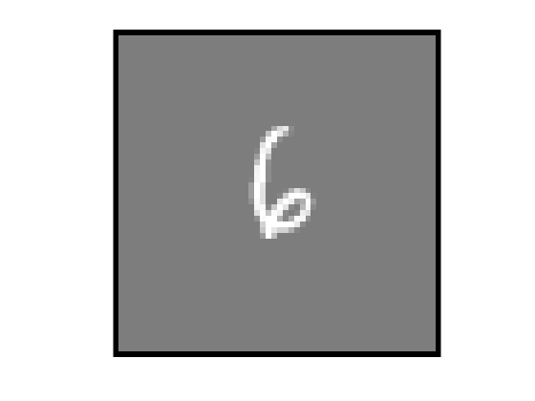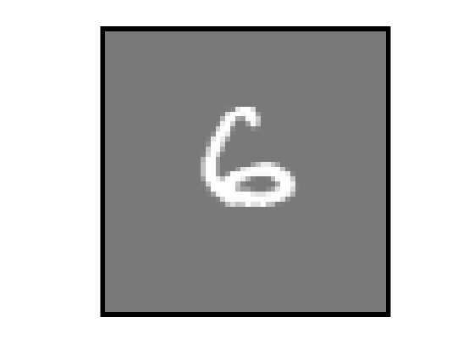

Fig. 2. Four examples of centered digit 6



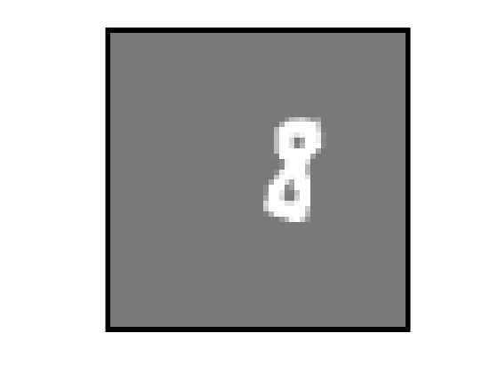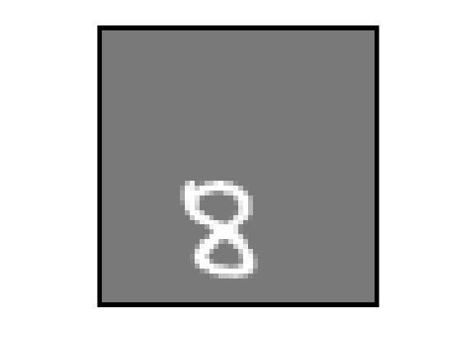

Fig. 3. Four examples of shifted digit 8

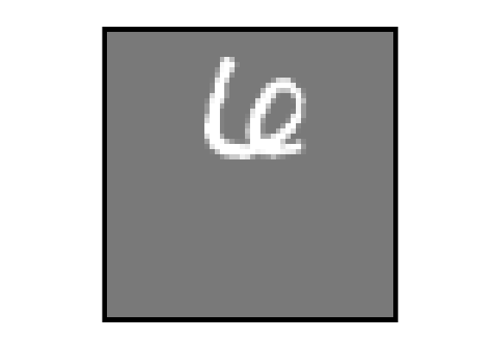

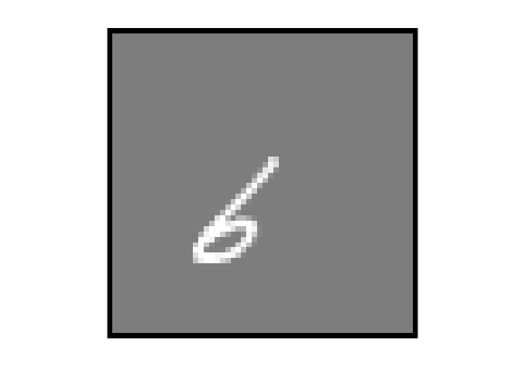

Fig. 4. Four examples of shifted digit 6